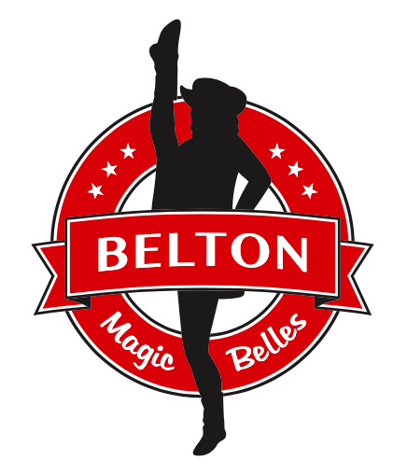
Dear Community Partner,
We would like to invite you to become a sponsor of the 2023-2024 Belton Magic Belles Drill Team. Since 1994, the Magic Belles have represented Belton High School and Belton ISD at school, sporting, and local community events, as well as competitive dancing events across the state. In previous years, the Magic Belles have won national and state titles, performed in the California Tournament of Roses Parade in 2019, and have supported many local charitable causes. Our team currently consists of 26 dancers who are eager to support the Belton Tigers and compete with the best drill teams in the state. The possibility of your generous contribution will help cover the expenses related to scholarships for travel, props, costumes, and production costs for this spring’s dance experience.
In return for your wonderful contribution, we would like to offer marketing publicity through our social media posts, show program ads, team banners and posters. Sponsorship packages will include a complimentary Magic Belles yard sign, show tickets, and an opportunity for the “best seats in the house” at the Spring Show. We also encourage Friends, Family and Forevers to support the BMB through a sponsorship package created just for you to show your love for the Belton Magic Belles.
The sponsorship levels are included in the attached sheet, or use the link below. Our Belton Magic Belles Booster organization is an exempt organization as described in Section 501 (c)(3) of the Internal revenue Code, so your donation will qualify as tax deductible. If you have questions, please contact Art Ortiz at 210-279-4704, or email the booster club at magicbellesboosters@gmail.com.
Please visit our website at www.beltonmagicbelles.com, for more information. To become a sponsor you can click on “Sponsors” to sign up or fill out the form attached and mail it to P.O. Box 2003, Belton, TX 76513. Contributions can be made payable with a check made out to Belton Magic Belles or via PayPal to paypal.com/us/fundraiser/charity/2281369.
The team is eager to wear their hats & boots and high kick for the Belton Tigers this season! Thank you in advance for your generous contribution and support of our amazing team of dancers bringing entertainment wherever they go…Belton Magic Belles Forever!
Respectfully,
Magic Belles Booster Club
P.O. Box 2003 / Belton, TX 76513
Belton Magic Belles
2023 - 2024 Sponsorship Levels
Diamond Sponsor $1,000
- Social Media Shout Out
- Autographed Team Poster to display at your business
- Your logo on the BMB Banner displayed at ALL Magic Belle events
- Yard Sign
- 4 Winter Show Tickets
- 4 Spring Show Tickets
- “Best seats in the house” at both shows
- Full page Spring Show ad
Gold Sponsor $500
- Social Media Shout Out
- Team Poster to display at your business
- Your logo on the BMB Banner displayed at ALL Magic Belle events
- Yard Sign
- 2 Winter Show Tickets
- 2 Spring Show Tickets
- ½ page Spring Show ad
Silver Sponsor $250
- Social Media Shout Out
- Team Poster to display at your business
- Your logo on the BMB Banner displayed at ALL Magic Belle events
- Yard Sign
- 1 Winter Show Ticket
- 1 Spring Show Ticket
- ¼ page Spring Show ad
Friends, Family & Forevers $100
- Social Media Shout Out
- Team Poster
- 1 Spring Show Ticket

BELTON HIGH SCHOOL
MAGIC BELLES DRILL TEAM
Magic Belles Booster Club
P.O. Box 2003
Belton, TX 76513

1. SPONSOR INFORMATION
CONTACT NAME:
BUSINESS NAME:
MAILING ADDRESS:
CITY, STATE, ZIP:
CONTACT EMAIL:
CONTACT PHONE NUMBER:
COMPANY WEBSITE:
*PLEASE LIST YOUR FULL ADDRESS SO WE CAN MAIL OR DELIVER YOUR ITEMS THROUGHOUT THE YEAR.

2. PLEASE CHECK YOUR SPONSORSHIP CHOICE

- DIAMOND $1000

- GOLD $500

- SILVER $250

- FRIENDS, FAMILY & FOREVERS $100

3. FILL OUT THIS FORM IN FULL AND RETURN IT WITH A CHECK PAYABLE TO BELTON MAGIC BELLES BY TUESDAY, AUGUST 1ST.

SEND PAYMENTS TO:
BELTON MAGIC BELLE BOOSTERS
P.O. BOX 2003
BELTON, TX 76513

OR GO ONLINE TO WWW.BELTONMAGICBELLES.COM AND SUBMIT YOUR FORM ONLINE. PAYMENT ONLINE THROUGH PAYPAL at paypal.com/us/fundraiser/charity/2281369.
4. PLEASE SUBMIT YOUR LOGO TO ART ORTIZ AT MAGICBELLESBOOSTERS@GMAIL.COM.

